Windows Log Analysis with PowerShell

Part 1: Understanding Windows Security Event IDs

1. Version check
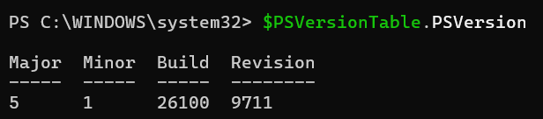

Part 2: Basic PowerShell Event Log Queries

1. View Recent Security Events
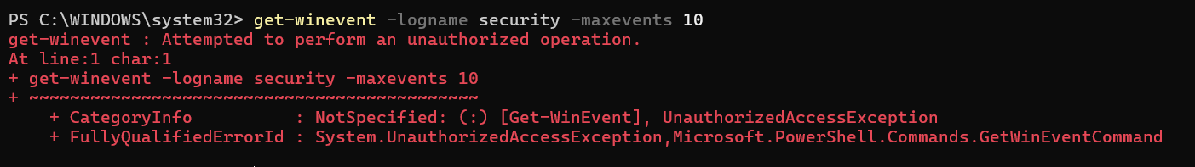

2. Filter by Event ID
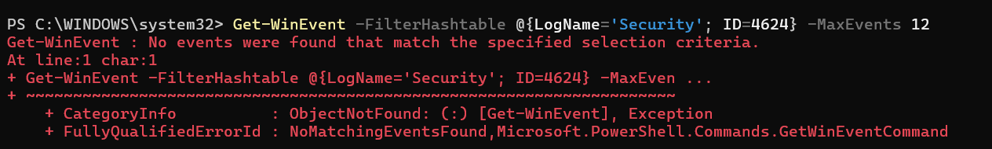

3: Filter by Time Range
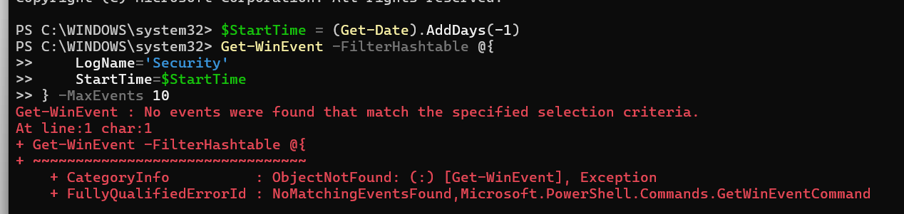

4. Count Events
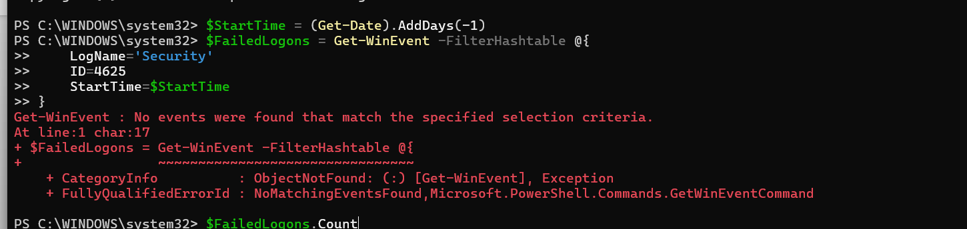

Part 3: Extracting Event Properties

1. Understanding Event Structure
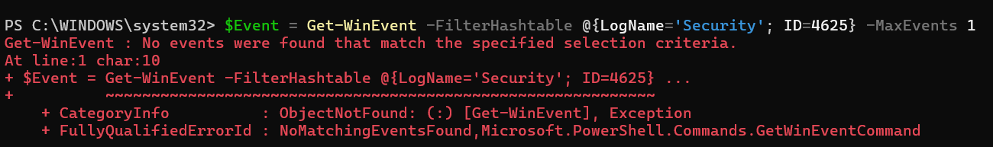

2. Extract Data from Failed Logons
+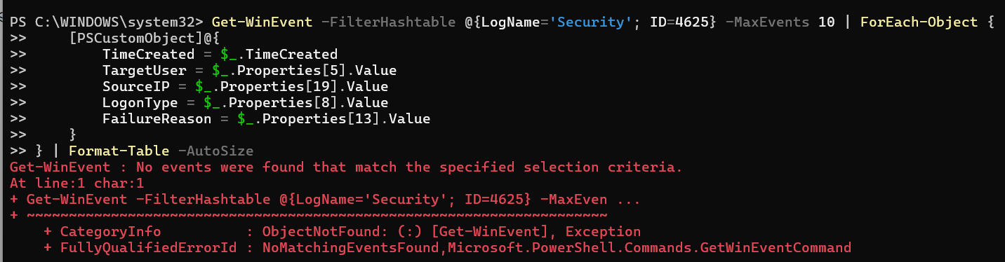

3. Analyze Failed Logon Attempts
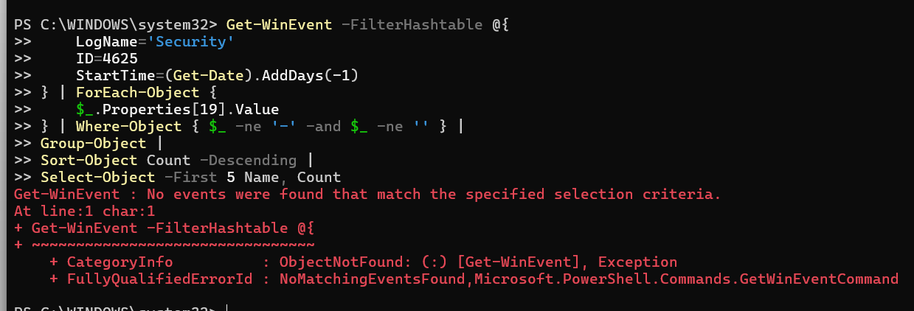

4. Identify Targeted Accounts
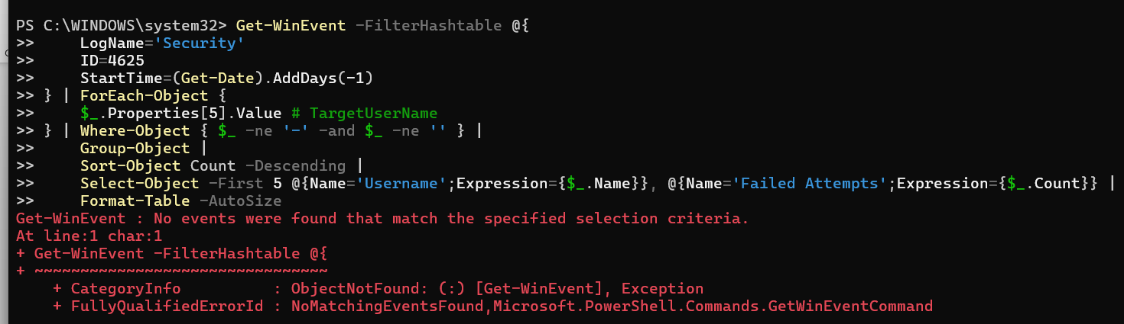

5. Analyze Logon Types
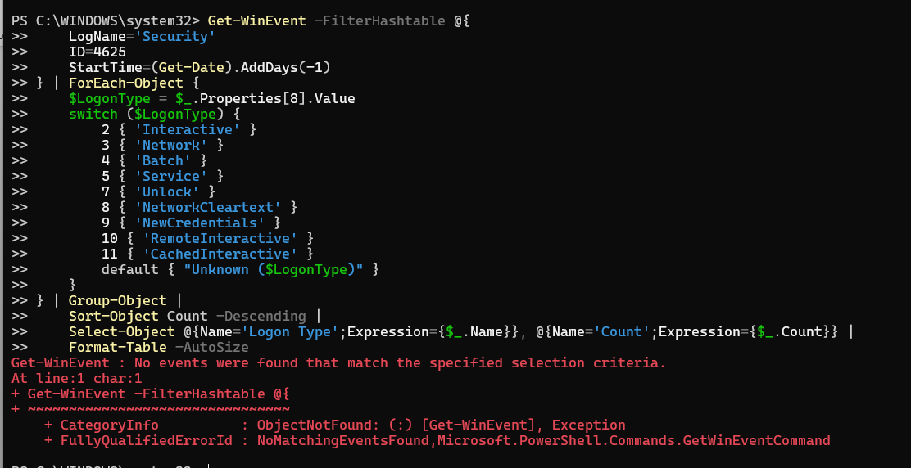

Part 4: Detecting Brute-Force Attacks

1. Identify Brute-Force Patterns
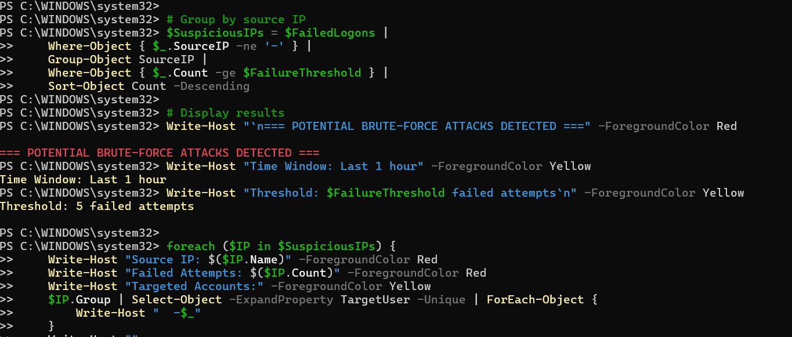

2. Generate Test Failed Logons
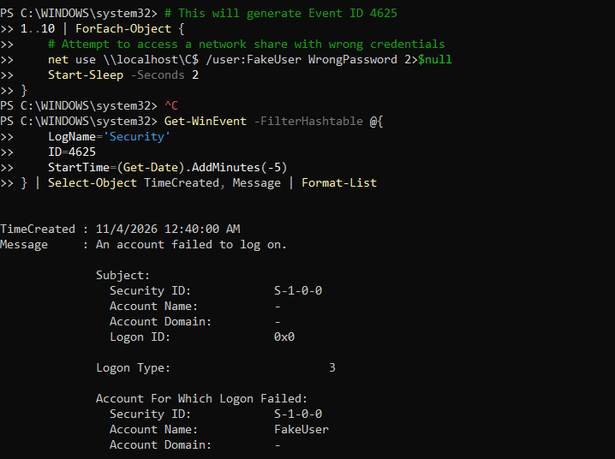

Part 5: Detecting Lateral Movement

1. Detect Explicit Credential Usage
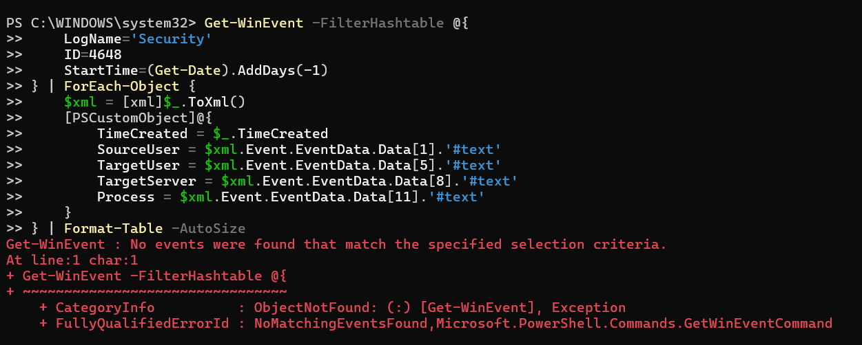
2. Detect Network Share Access
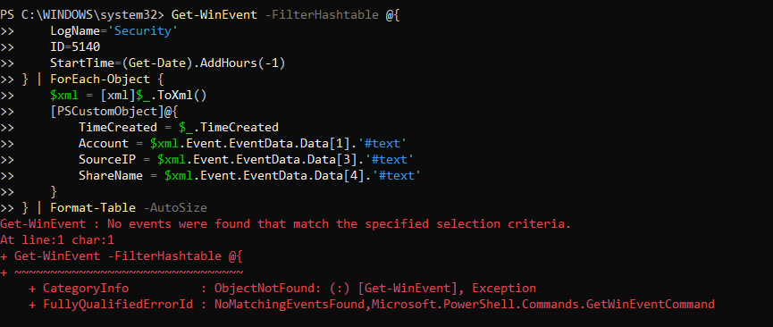

Part 6: Detecting Privilege Escalation

1. Monitor Admin Group Changes
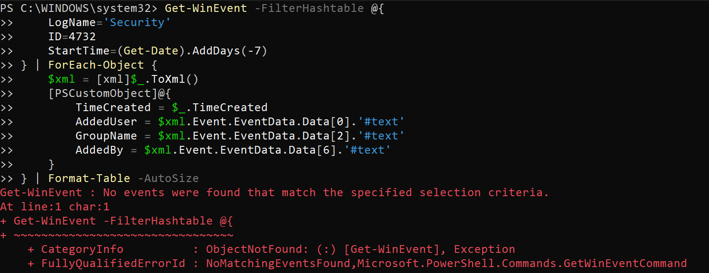

2. Detect Special Privilege Assignments
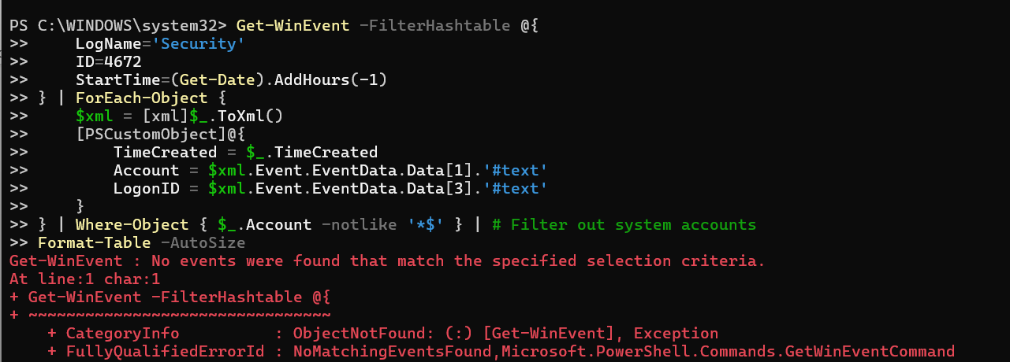

Part 7: Creating Comprehensive Analysis Scripts

1. Create a Complete Security Analysis Script
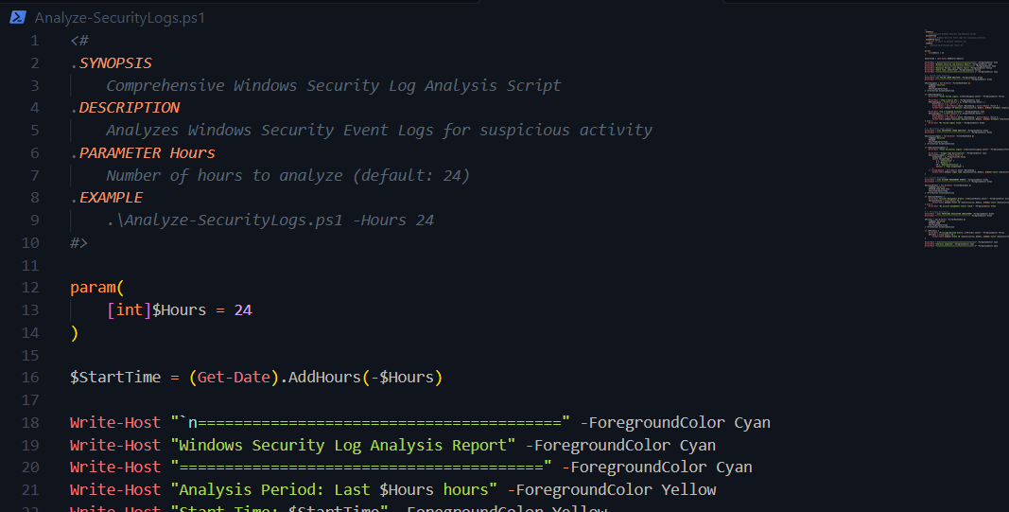
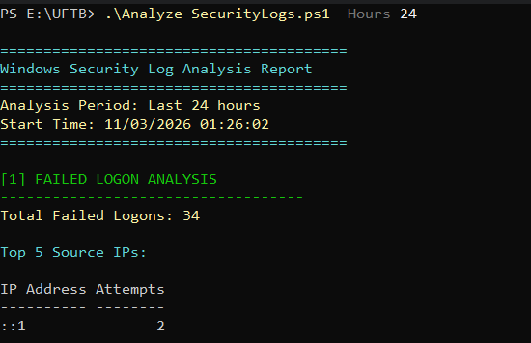

Part 8: Exporting Results

1. Export to CSV
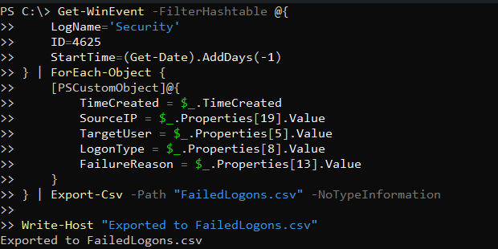

2. Export to HTML Report


